| Course name | Numerical Modelling & Simulation in Scilab Xcos |
| --- | --- |
| **Lesson name** | **Numerical Modelling of Student Electric Racing Vehicle using Drive Cycle data in Scilab-Xcos** |
| **Lesson objective** | **Practice blocks &** **acquaint to use GUI of Scilab-Xcos** |
| Created by | Bharath Kumar P |

**Problem statement:** Model Student Electric Racing Vehicle for Drive Cycle in Scilab Xcos to plot the Wheel Torque, Wheel Speed, Motor Torque, Motor Speed and Battery Current in Scilab-Xcos.

**Drive Cycle Graph:**

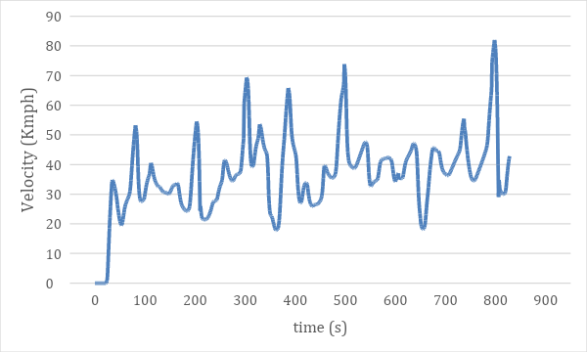

**Model Inputs:**

| **Sl No** | **Parameter** | **Value** | **Units** |
| --- | --- | --- | --- |
|  | 1. **Chassis** |  |  |
|  | 1. Coefficient of rolling resistance | 0.015 |  |
|  | 1. Gross Vehicle Mass | 320 | Kg |
|  | 1. Gravity constant | 9.81 | m/s |
|  | 1. Grade Angle | 0 | degree |
|  | 1. Velocity | From the Drive Cycle data | Kmph |
|  | 1. Frontal Area | 1.8585 | m^2 |
|  | 1. Air Density | 1.225 | Kg/m^3 |
|  | 1. Drag Coefficient | 0.15 |  |
|  | 1. Radius of wheel | 0.2286 | m |
|  | 1. **Transmission** |  |  |
|  | 1. Gear Ratio | 15 |  |
|  | 1. Transmission Efficiency | 85 | % |
|  | 1. **Motor** |  |  |
|  | Motor Efficiency | 90 | % |
|  | 1. **Battery** |  |  |
|  | 1. Motor Controller Efficiency | 85 | % |
|  | 1. Battery Voltage | 540 | V |
|  | 1. Drive cycle distance (One Lap) | 0.825 | Km |
|  | 1. No of laps | 12 | Km |
|  | 1. Battery Initial SOC | 100 | % |
|  | 1. **Cell** |  |  |
|  | 1. Cell Voltage | 3.7 | V |
|  | 1. Cell Capacity | 6.6 | Ah |